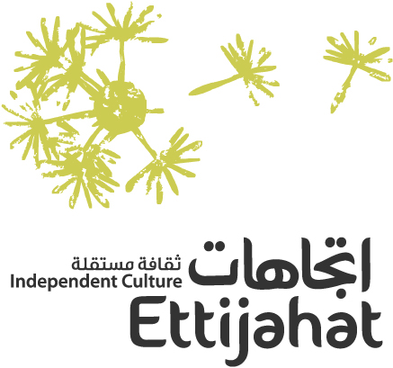




Create Syria: A Space to Explore Arts and Social Change | Fourth Edition
Socially Engaged Art in a (Dis)Connected World

Application Form
Please read the general guidelines manual before filling out the form. Estimated time of reading: up to 15 minutes!

Requested documents:
Please make sure to include all the following requested documents in your application before sending your file.
- The completely filled Application Form in Arabic or in English
- The applicant’s up-to-date CV with samples of previously implemented projects if applicable
- A clear copy of the applicant’s ID or passport
- A portfolio of complete work of the group and/or the initiative if you are applying as a group or an initiative
- Optional: A video of no more than two minutes in which the applicant explains their reasons for applying and how their proposal responds to the selection criteria

Please return the completed form, along with the above-mentioned documents to: createsyria@ettijahat.org
For any inquiries, do not hesitate to contact us at the same address. Once we receive your application, we shall send you an 'Electronic Receipt Notice'. If you do not receive this notification, please re-send your application.

- Participation Form
1. Personal Information
Full name in Arabic
Full name in English (as used in your passport)
Age
Sex (Male, Female, Other, Prefer not to say)
Current Nationality (ies)
Address: Building, Street, City, Country
Legal status in your place of residence (national, refugee, resident, unregistered)
Email
Mobile number
Current occupation (name and location of the institution)
How did you know about the programme?
Your professional short bio (250 words)

2. Education (1 being your most recent diploma)
 | University | Faculty | Diploma | Year of Graduation | Academic Score
1
2
3

3. Trainings received (1 being your most recent training)
 | Organizer | Topic | Duration | Year
1
2
3

4. Artistic Projects if any (1 being your most recent project)
 | Project | Brief Description | Year- Location | Link
1
2
3

5. Language proficiency (advanced, good, average, beginner)
 | Language | Level
1 | Arabic
2 | English
3 | French
4 | Other languages (please specify)

6. What kind of relation do you have with the Arab region?
Please check (X) and elaborate all that apply
Place of birth
Place of birth of parents/ ancestors
Current place of residence
For studying purposes
Work-related
General Interest
Language spoken
Previous partnerships
Other

- Project Proposal
- Title of the project idea
This can be a temporary title

- Art Field
  - What art field(s) does the project idea fall under? (100 words)

  - Does the project engage or tackle any other field even if not art-related?
If yes, please specify (100 words)

- Idea and Work Context
  - What problems or need triggered the idea?
Make sure to share qualitative and comprehensive information that may include, for example, historic and scientific facts, statistics and percentages, personal information- 300 words

  - What is the idea that you want to work on and how did you come to think of it?
Please describe the idea, in the form of a narrative paragraph, with a focus on its nature and specificity, in addition to the objectives that you want to achieve, and the artistic tools you will use- 300 words

  - With whom will you execute the project idea, what will it achieve and what kind of change do you hope to see as a result of this achievement?
What community(ies) would you like to work with? what is the nature of your relationship with this community? What do you hope would change in this community as a result of your idea? 300 words

  - What (economic, social, environmental etc.) challenges or problems you might face during your work and what do you suggest to overcome these hurdles?
Based on your knowledge of the community concerned and its problems, what might prevent you from executing your idea and what solutions do you anticipate to overcome these obstacles? 300 words

  - What effects do challenges resulting from current world crises (whether health, security or social) have on your project idea, and what do you suggest to overcome them?
Did any of the current crises (health crisis, wars, displacement, economic crises) have an impact on your project idea? Will your project remain feasible if the crisis continues to unfold and what solutions do you have in mind? 300 words

- Learning exchange and ways to develop the project idea
            - If selected to participate in the first stage of the programme, what personal skills and aspects of your idea would you like to develop? 200 words

      - If you are shortlisted to receive idea development support, is there a preferred art mentor you would like to work with on developing your project idea? (if you do not have anyone specific in mind, please specify the fields you would like to develop with the assistance of a mentor)
Please mention the name of your art mentor, how do you know him/her, the reasons of your choice, a short bio of your mentor and his/her email - 150 words

      - Are you willing to develop your project proposal with a fellow participant in the program? What are the most important opportunities and challenges for cooperation? 200 words

      - Do you see yourself cooperating with peers from other countries or working with different communities? 200 words

- Would you like to participate in workshops or educational sessions organized by a certain institution, to help you develop your project idea?
 | Institution | Email | Topic
1
2
3

6. Please provide us with a timeline of three to six months to explain what you would like to develop, if selected. Please highlight the most important dates in your timeline. 300 words

- Please provide us with a preliminary budget for the project, divided into two phases (idea development and implementation)
Phase | Item | Unit 1 | Unit 2 | Price (euro) | Total
Idea Development
Implementation
Total

I agree to share the information submitted in this form with Ettijahat, CounterPoints, British Council, and the Jury for the purpose of processing my application. If accepted, I agree to abide by all the terms and conditions of my participation in the Create Syria programme and to commit to all its activities.

Name:
Date:
Signature:

